**Program no___4______**

**Program Title______Push Button LED___________**

**Aim To push a button and get the light to blink**

**Hardware Required**

* Arduino Board
* push button
* LED light

**Circuit Diagram**

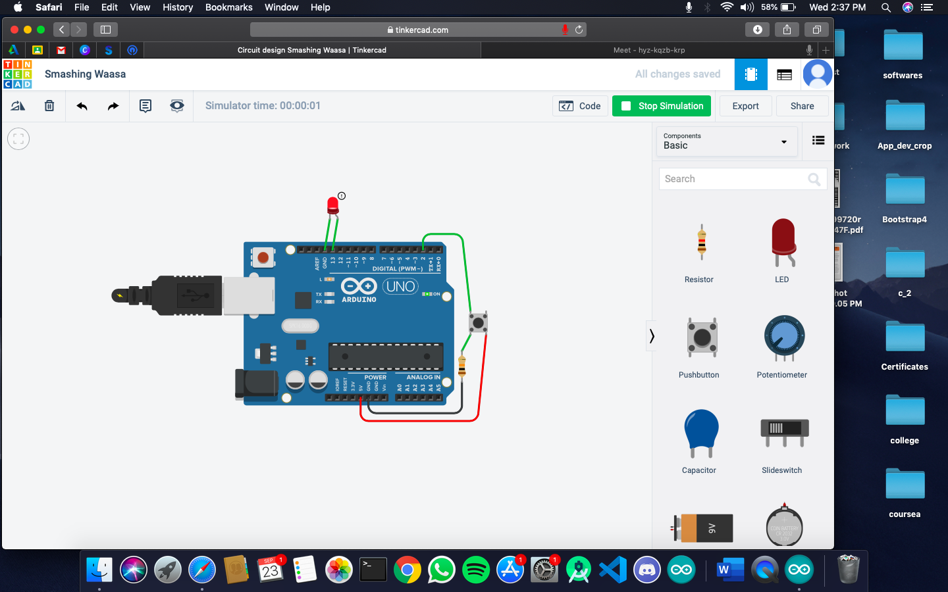

**Code:int buttonpin=2;**

**int ledpin=13;**

**int buttonstate=0;**

**void setup() {**

**// put your setup code here, to run once:**

**pinMode(13,OUTPUT);**

**pinMode(2,INPUT);**

**}**

**void loop() {**

**// put your main code here, to run repeatedly:**

**buttonstate=digitalRead(buttonpin);**

**if(buttonpstate==HIGH)**

**{digitalWrite(13,HIGH);}**

**else**

**{digitalWrite(13,LOW);}**

**}**

**Observation /Output**

**the light will blink when you push the button.**